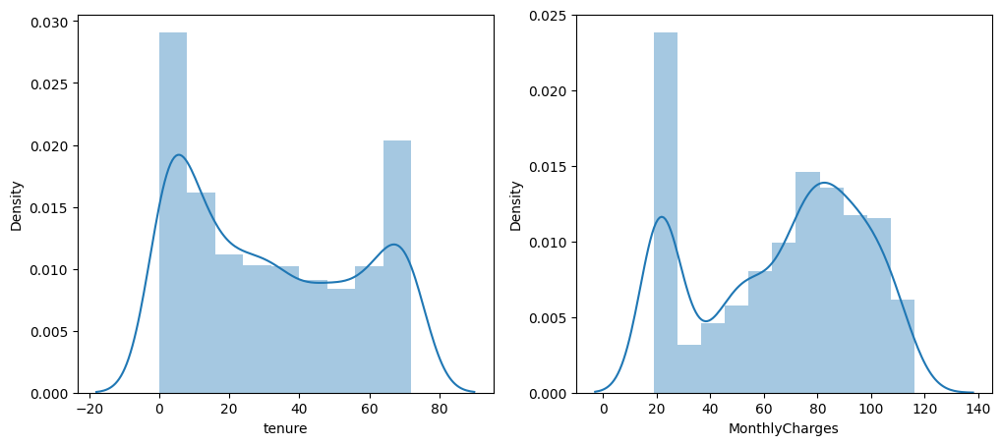

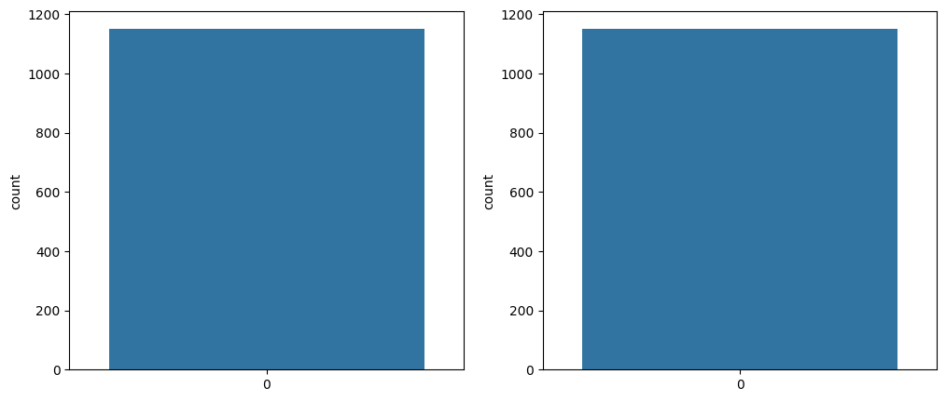

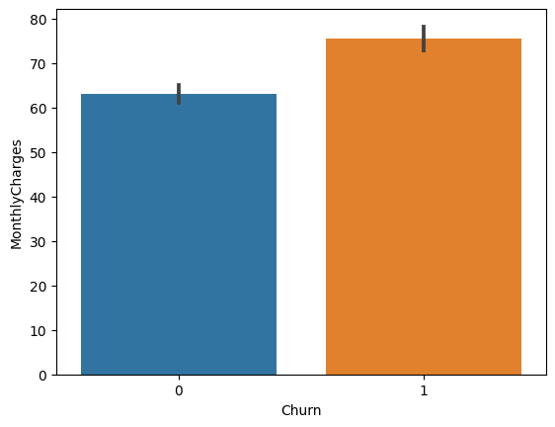

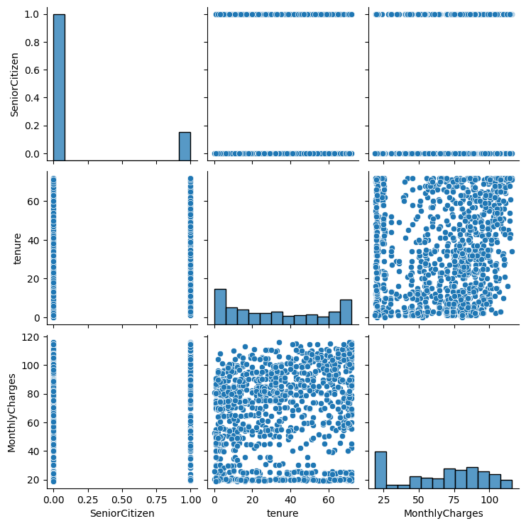

Accuracy Score : 0.8202494497432135

Accuracy Test : 0.7419354838709677

Logistic Regression

Confusion Matrix

[[116 41]

[ 47 137]]

Classification Reprot

precision recall f1-score support

0 0.71 0.74 0.72 157

1 0.77 0.74 0.76 184

accuracy 0.74 341

macro avg 0.74 0.74 0.74 341

weighted avg 0.74 0.74 0.74 341

Accuracy Score : 0.9926632428466617

Accuracy Test : 0.8035190615835777

Random Forest

Confusion Matrix

[[108 49]

[ 18 166]]

Classification Reprot

precision recall f1-score support

0 0.86 0.69 0.76 157

1 0.77 0.90 0.83 184

accuracy 0.80 341

macro avg 0.81 0.80 0.80 341

weighted avg 0.81 0.80 0.80 341

Accuracy Score : 0.8459280997798972

Accuracy Test : 0.7800586510263929

KNN

Confusion Matrix

[[ 98 59]

[ 16 168]]

Classification Reprot

precision recall f1-score support

0 0.86 0.62 0.72 157

1 0.74 0.91 0.82 184

accuracy 0.78 341

macro avg 0.80 0.77 0.77 341

weighted avg 0.80 0.78 0.77 341

Accuracy Score : 0.8459280997798972

Accuracy Test : 0.7800586510263929

SVM

Confusion Matrix

[[ 98 59]

[ 16 168]]

Classification Reprot

precision recall f1-score support

0 0.86 0.62 0.72 157

1 0.74 0.91 0.82 184

accuracy 0.78 341

macro avg 0.80 0.77 0.77 341

weighted avg 0.80 0.78 0.77 341

Accuracy Test : 0.7947214076246334

ANN model

Confusion Matrix

[[129 28]

[ 42 142]]

Classification Reprot

precision recall f1-score support

0 0.75 0.82 0.79 157

1 0.84 0.77 0.80 184

accuracy 0.79 341

macro avg 0.79 0.80 0.79 341

weighted avg 0.80 0.79 0.80 341



